Birding along the Silk Road - Uzbekistan

There is no better destination in Central Asia for a mix of a Birding & Culture tour than in Uzbekistan. If you visit any of the ancient cities of Tashkent, Samarkand or Bukhara it will be obvious how rich these cities were during the Middle Ages and how much they still retained of the original splendor of architecture and traditions. As we follow the steps of the Silk Road we will be amazed how variable the scenery can be from high mountains through river valleys and lakes down to semi-deserts and the Kyzyl Kum desert itself.
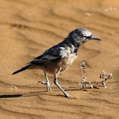
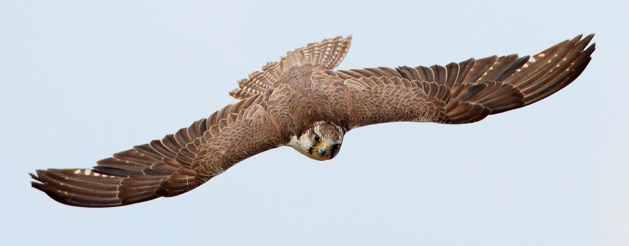
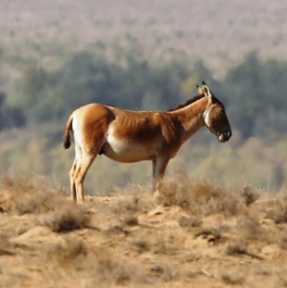
Obviously all these different habitats offer a wide variety of birds & other wildlife. In the hilly region we will look for raptors which include Himalayan Griffon Vulture, Griffon Vulture, Bearded Vulture, Long-legged Buzzard, Shikra, Saker Falcon and many more, while the most special bird to look for will be Pander’s Ground Jay in the desert where we also have a chance for Asian Desert Warbler, Desert Finch, Desert White-throat & Streaked Scrub Warbler.

In between the hills and the deserts we visit diverse habitats where we should add such various species as Turkestan Tit, Grey-necked - & White-capped Bunting, Eastern Rock Nuthatch, Turkestan Shrike, White-winged Woodpecker, Asian Paradise Flycatcher, Finsch’s Wheatear, White-throated Robin, Sykes Warbler, Menetries’s warbler, Rosy Starling and many more.
What is more, beside the excellent species of birds there is a good chance to see some other interesting wildlife, like Goitered Gazelle, Wild Asian Ass, Przewalski’s Horse and various reptiles, unique wildflowers and rare butterflies.
Fact File
- 8 days in Uzbekistan visiting high mountains, river valleys, semi-deserts and deserts
-start and finish in Tashkent, Uzbekistan; extension possibility to Kazahstan
-using 4 accommodations at Chimgan, Tashkent, Samarkand, Bukhara
Highlights
- visiting great protected areas such as Chimgan Mt., Tien Shan, Kyzyl Kum Desert
- wide variety of habitats with interesting birds, mammals, butterflies, reptiles
- following the historical Silk Road
- plenty of raptors, and several owl species, all 10 woodpeckers of Europe
- unique scenery of the Westernmost edge of the Asiatic steppes & a former volcano in the Slovakian hilly region
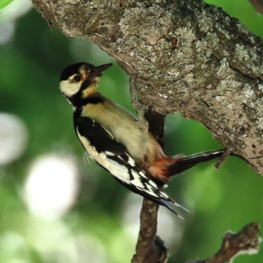
- mediaeval and ancient towns of Tashkent, Samarkand & Bukhara with traditional lifestyle, unique customs & incredibly rich cultural traditions
Accommodation
1 overnight flight from London to Tashkent, 1 night at Chimgan Mt. with perfect on-site birding, 1 night in Tashkent, 2 nights in Samarkand, 2 nights in Bukhara
Day 1
Start from London to Taskent, arrival on 2nd day early morning.
Day 2
After arriving to Tashkent in the morning we drive up to Chimgan Mountain, which is part of Chatkal Mountain Range in the Western Tien Shan. Best birds - Masked Wagtail, White-crowned Penduline Tit, Rose-coloured Starling, Long-legged Buzzard, Booted Eagle, Shikra, Turkestan Tit, Yellow-breasted Tit & Rufous-naped Tit.
Day 3
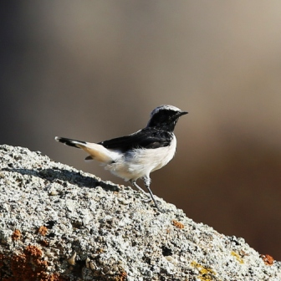
Birding at Chimgan. Rock Sparrow, Common Rosefinch, White-winged Woodpecker, Asian Paradise Flycatcher, White-capped Bunting, Golden & Indian Oriole, Black-,European Griffon & Himalayan Griffon Vulture, Golden Eagle. Down to Tashkent, some sightseeing in the capital city. Stay in Tashkent
Day 4
Travel from Tashkent to Samarkand, birding on the way. Eurasian Rollers & Bee-eaters, European Griffon Vulture & Egyptian Vulture. Lesser Kestrel, Saker Falcon, Variable Wheatear & Eastern Rock Nuthatch. Afternoon/evening sightseeing at amazing Samarkand.
Day 5
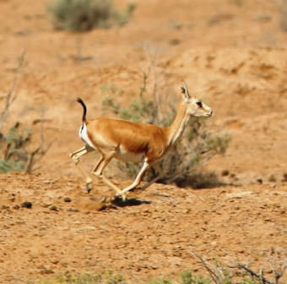
Birding towards and at Takta-Karacha Pass. Finsch’s Wheatear, Upcher’s Warbler, Eastern Orphean Warbler, Grey-headed Goldfinch, White-winged Woodpecker, Yellow-breasted Tit, Turkestan Tit, Turkestan Shrike, White-throated Robin, Eastern Olivaceous Warbler, Eastern Orphean Warbler, Hume’s Leaf Warbler, Hume’s Short-toed Lark & White-capped Bunting, Pied Wheatear, Chukar, Rock Bunting and Eastern Rock Nuthatch.

Day 6
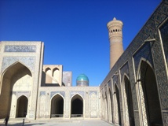
Birding at Zeravshan River & at a Fishpond system: Rufous-tailed Scrub Robin, Long-tailed Shrike, Savi’s Warbler, Clamorous/Turkistan Reed Warbler, Reed Bunting, Paddyfield Warbler, Blyth’s Reed Warbler, Sykes Warbler, Thick-billed Warbler, White-crowned Penduline Tit, Moustached Warbler, Common Black-backed & Masked Wagtail, Rufous-tailed Scrub Robin, Pied Bush-chat, Rustic Bunting, Eurasian Rollers, Blue-cheeked Bee-eaters, Purple Heron, Ferruginous Duck. Sightseeing at splendid Bukhara.
Day 7
Deep in the famous Kyzyl Kum desert, main target is Pander's Ground Jay, Isabelline Wheatear, Blue Whistling Thrush & Streaked Scrub Warbler, Blyth’s Warbler, Black-bellied Sandgrouse, Black-headed Wagtail, Southern/Steppe Grey shrike, Desert White-throat, Menetries’s Warbler, Rosy Starling. Potential mammals: Przewalski’s Horse, Goitered Gazelle & Wild Asian Ass or Kulan. Night at Bukhara.
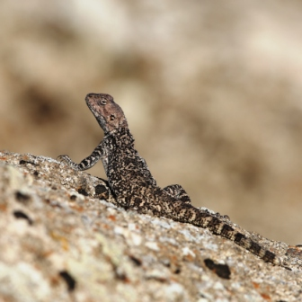
Day 8
Short midday flight from Bukhara to Tashkent, followed by a connection either to London or Almaty, Kazahstan.
Day 9
Arrival to London or Kazahstan

